DIS-AM,C-Taino-2015 Dec 10

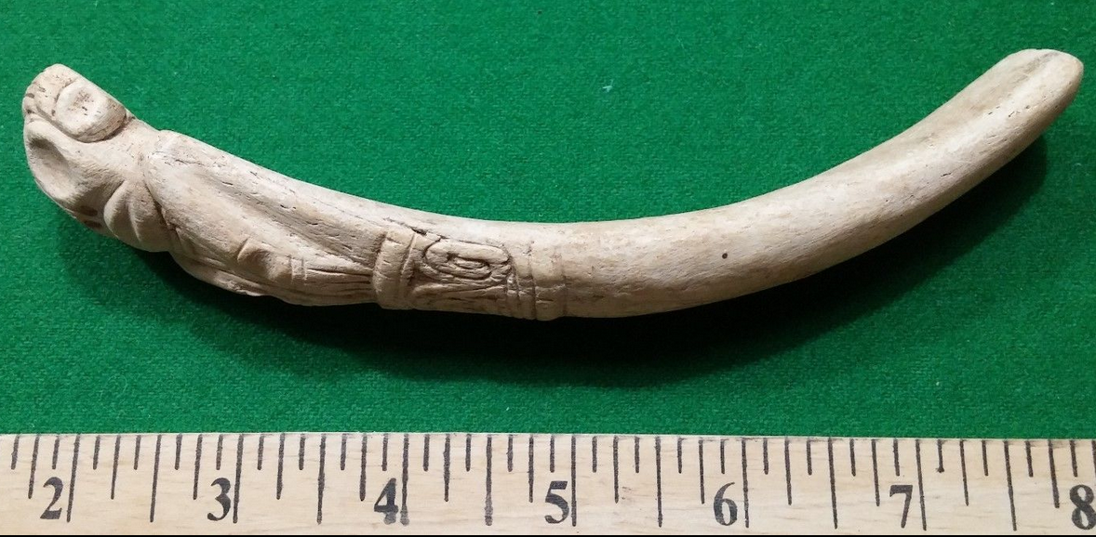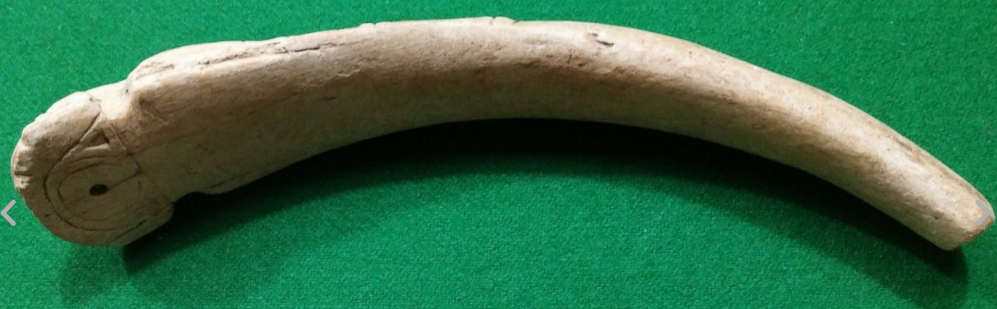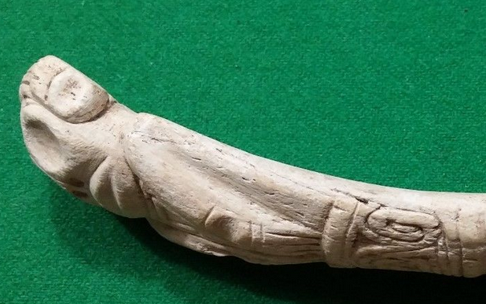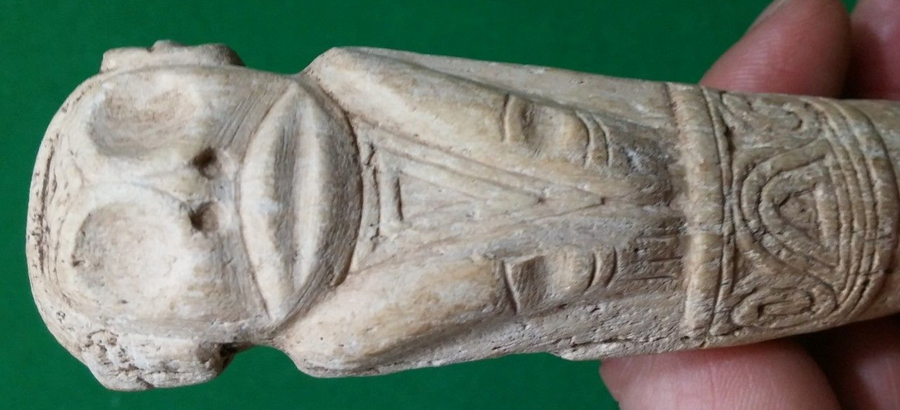

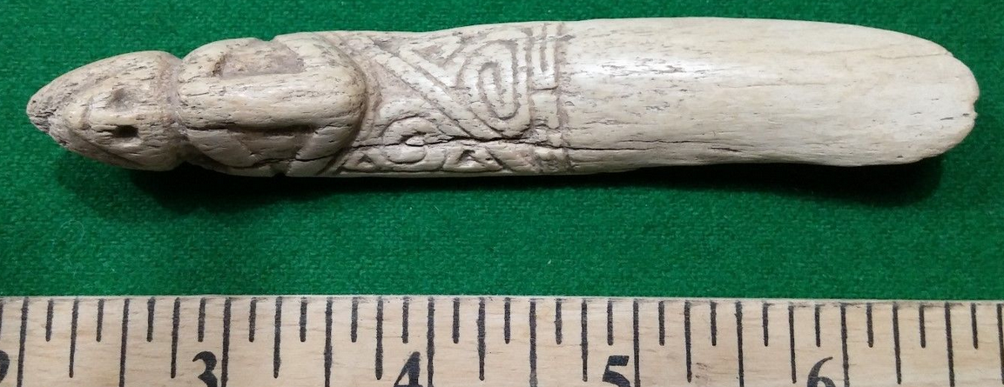 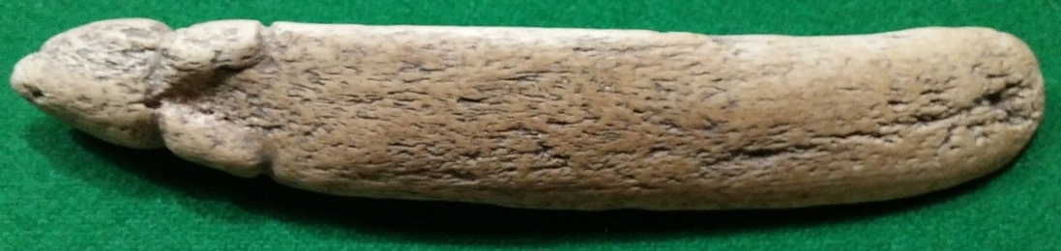

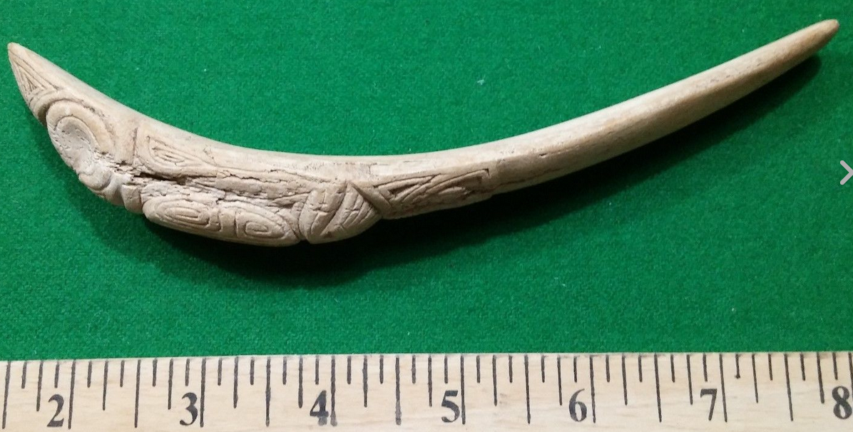

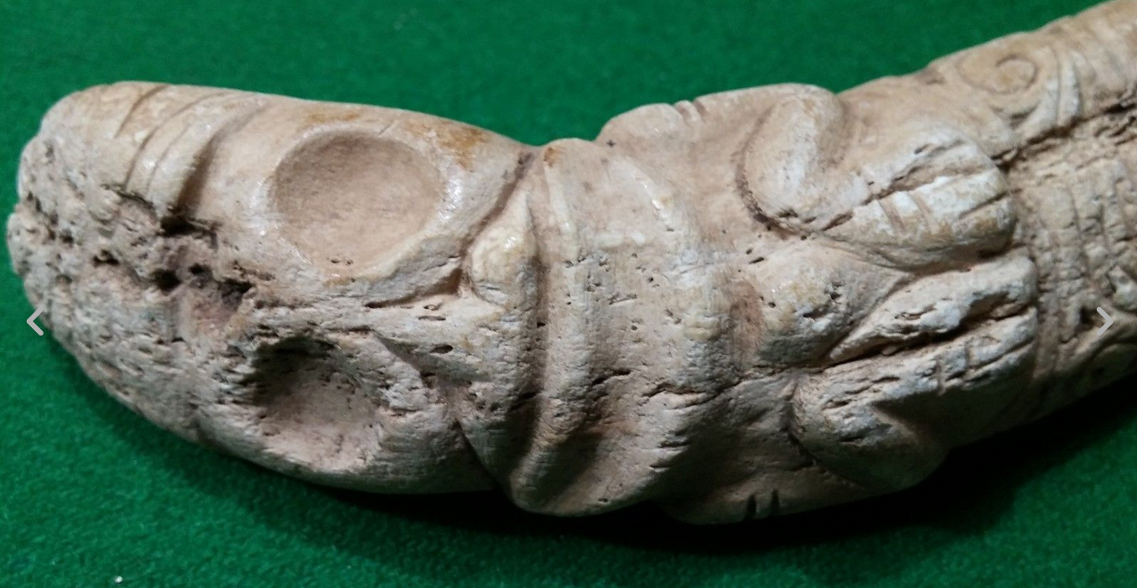

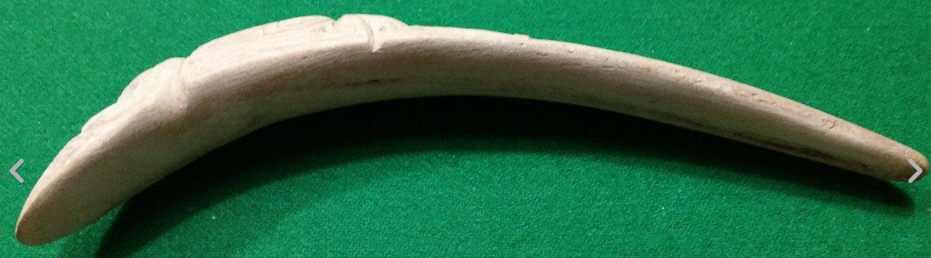

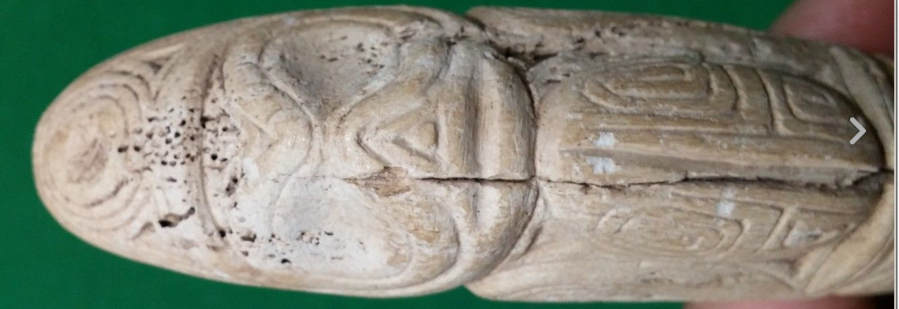

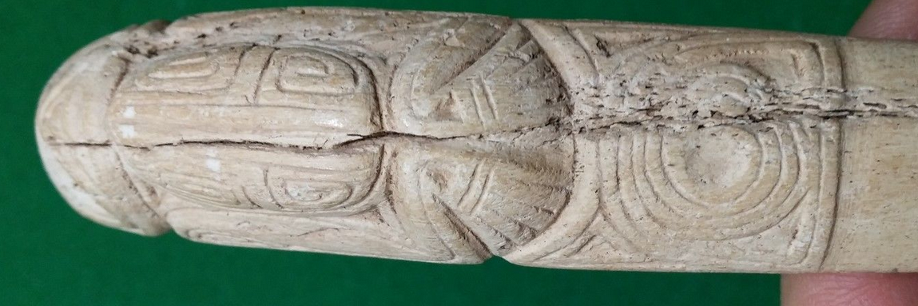

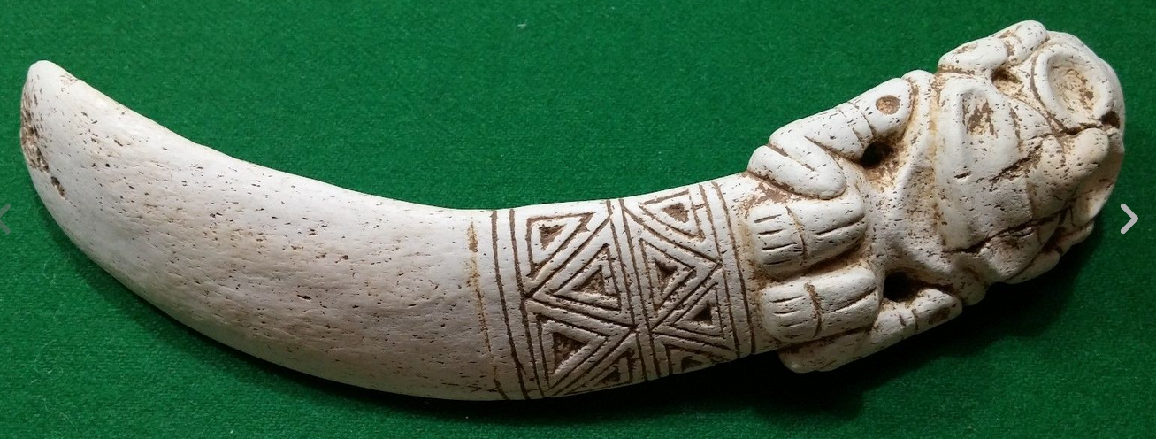

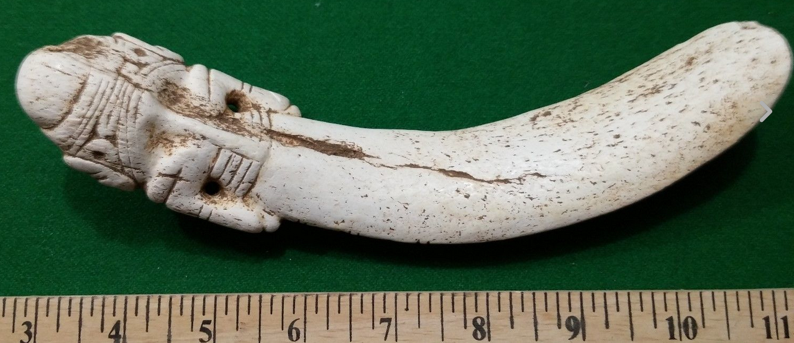

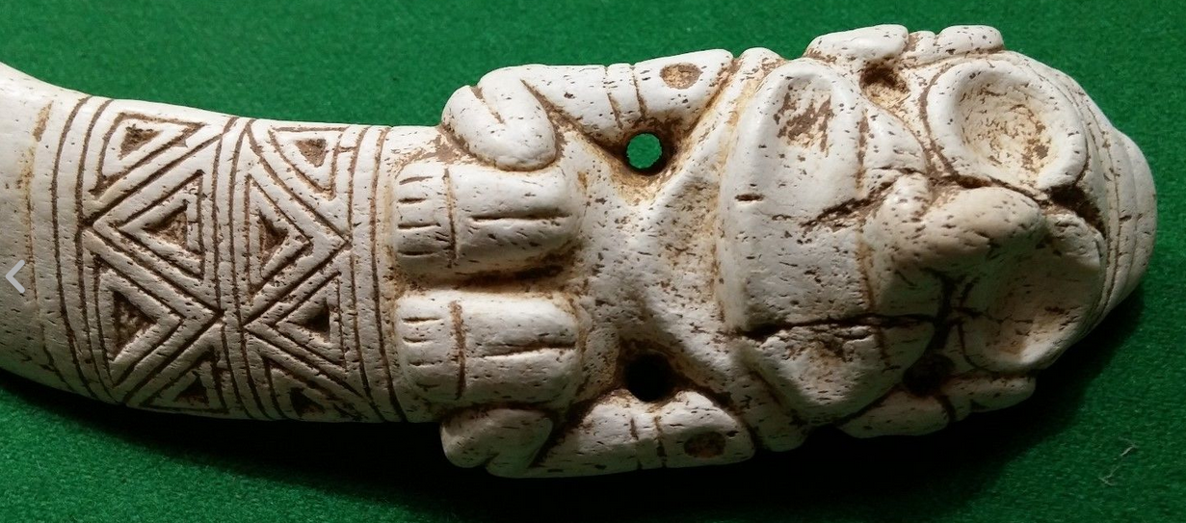

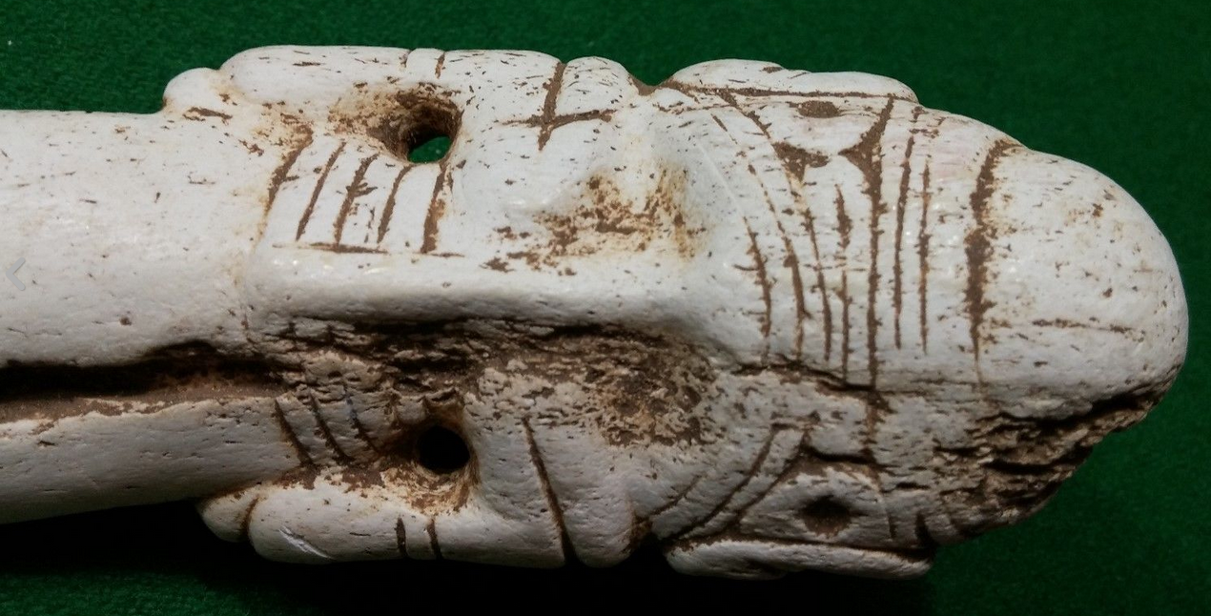

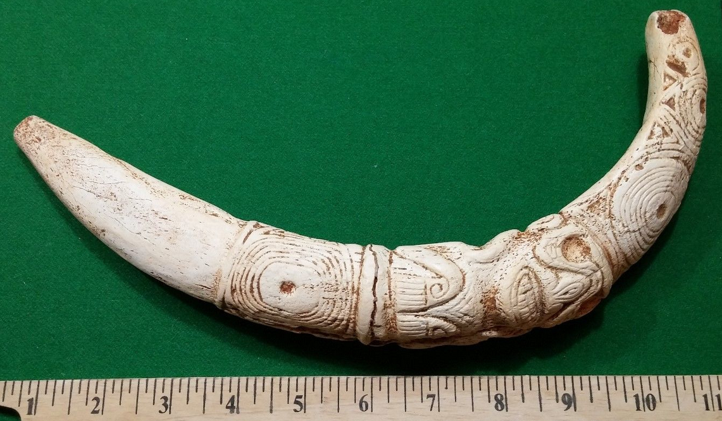

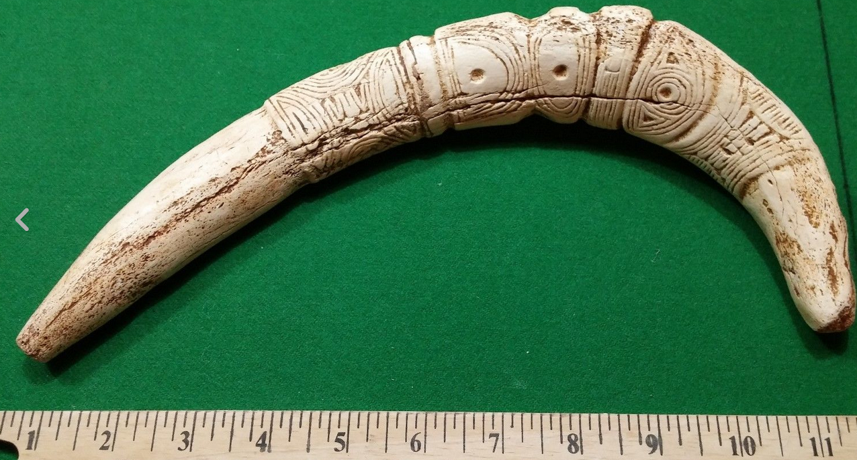

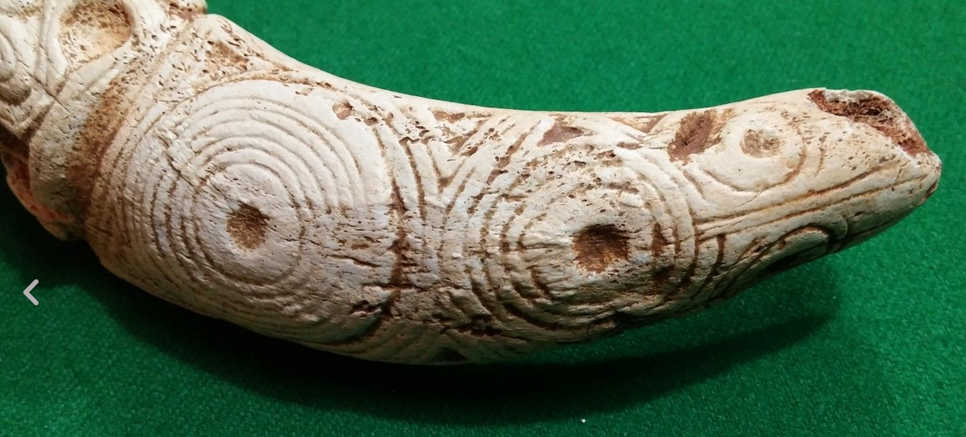

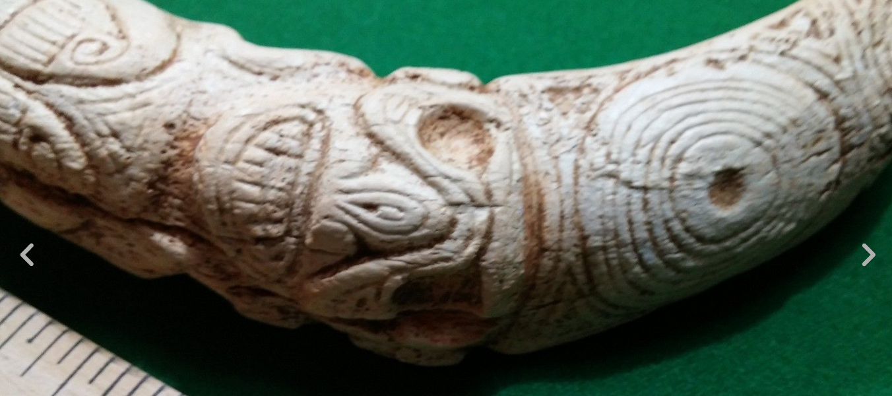

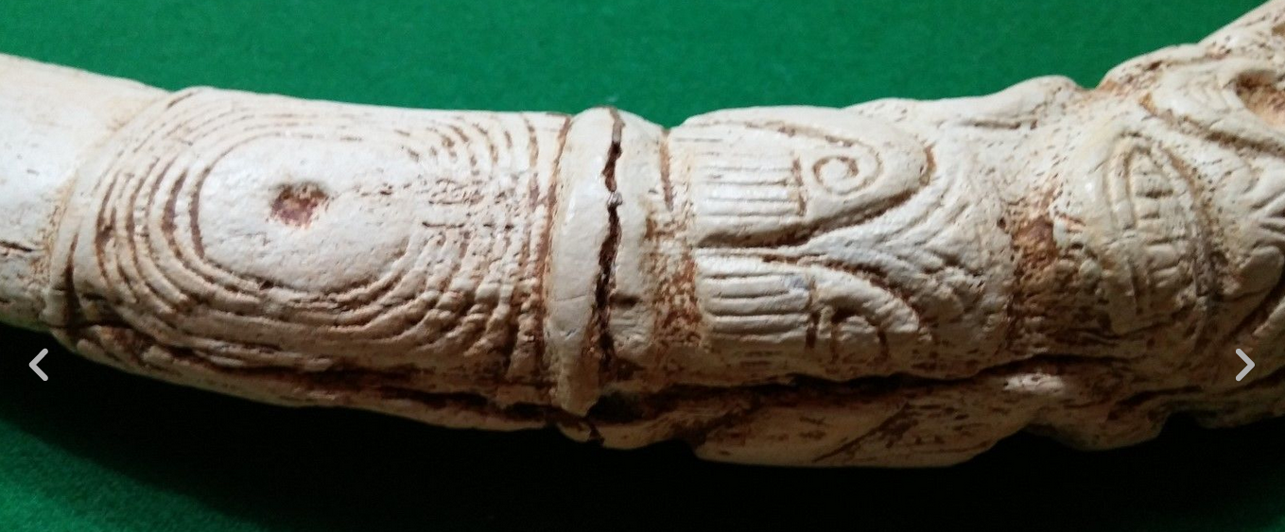

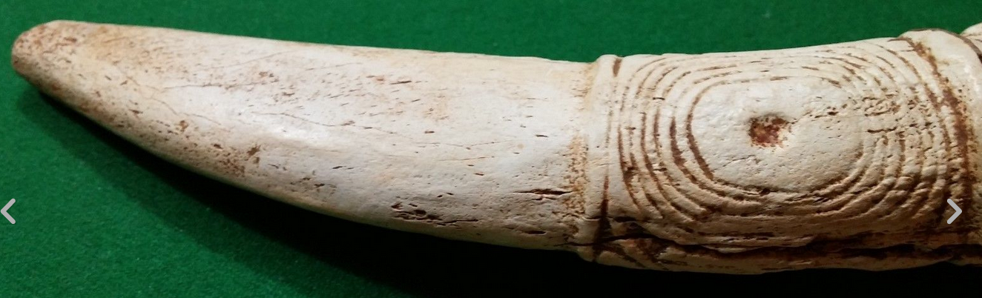

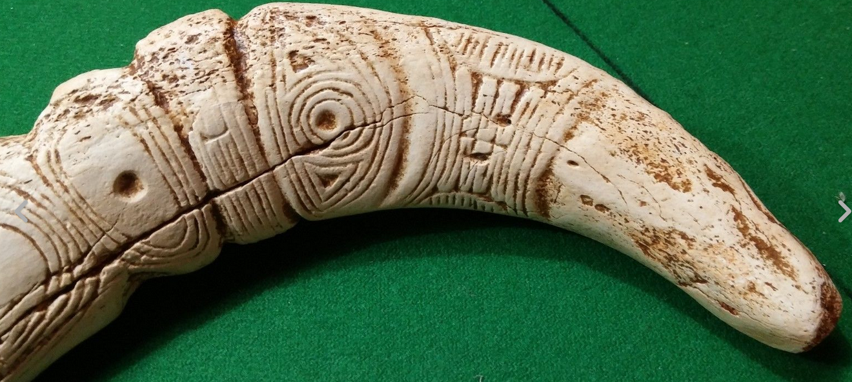

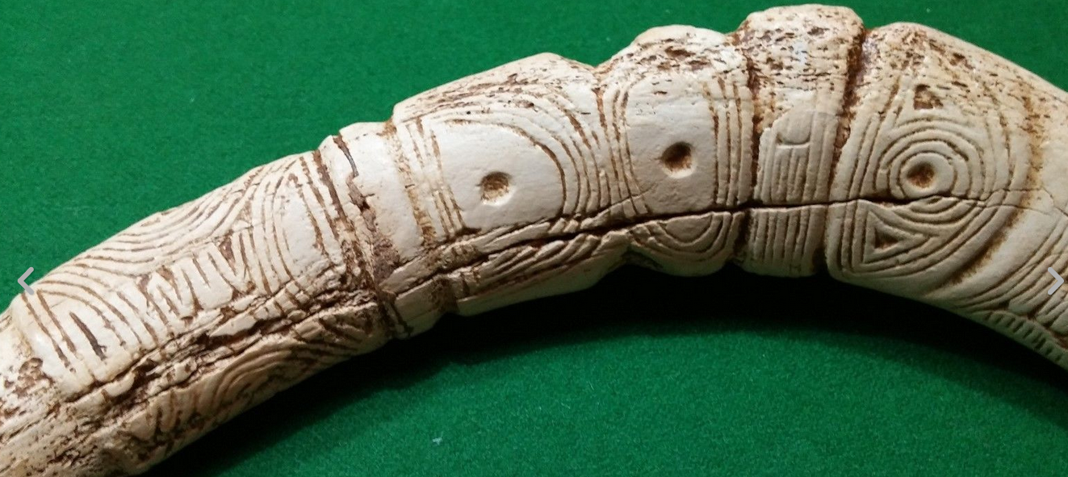

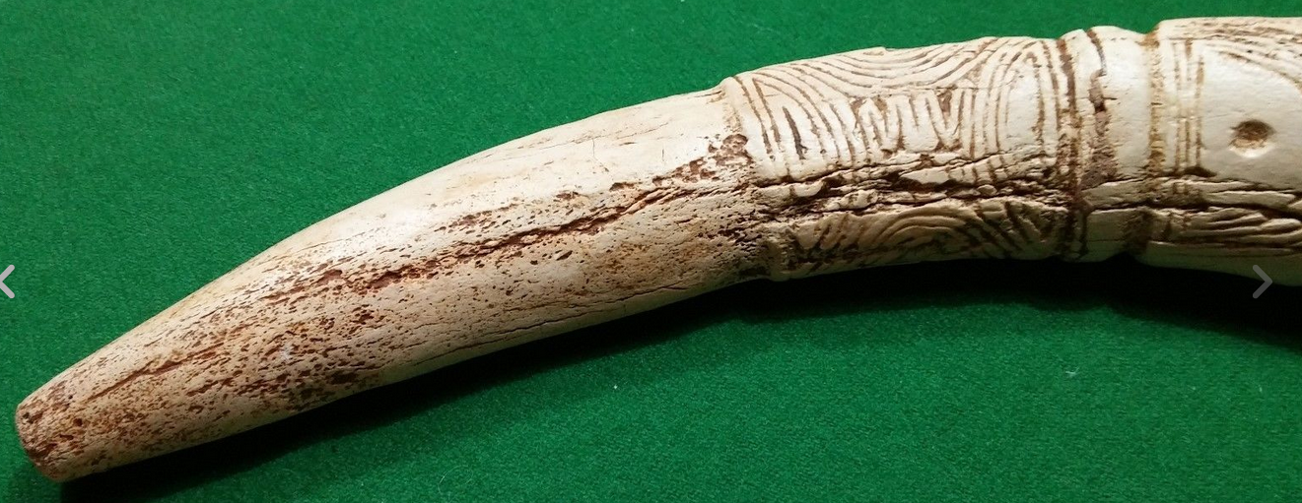

Sold by [user1billion](http://myworld.ebay.com/user1billion) ( [770](http://feedback.ebay.com/ws/eBayISAPI.dll?ViewFeedback&userid=user1billion) )

### Delivery package 1 of 1

Estimated delivery Wednesday, Dec 16, 2015 - Monday, Dec 21, 2015

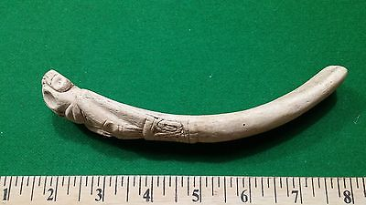

#### [Taino Bone Spatula (Vomet Stick) - Pre Columbian](http://www.ebay.com/itm/161906296155)

|  |  |
| --- | --- |
| Item price | $99.00 |
| Quantity | 1 |
| Item number | 161906296155 |
| Shipping service | Expedited Shipping from outside US |

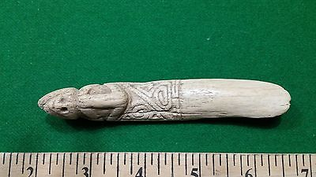

#### [Taino Bone Spatula (Vomet Stick) - Pre Columbian](http://www.ebay.com/itm/161906297038)

|  |  |
| --- | --- |
| Item price | $69.00 |
| Quantity | 1 |
| Item number | 161906297038 |
| Shipping service | Expedited Shipping from outside US |

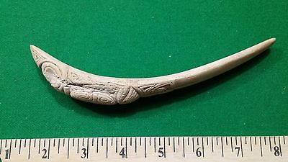

#### [Taino Bone Spatula (Vomet Stick) - Pre Columbian](http://www.ebay.com/itm/161906301230)

|  |  |
| --- | --- |
| Item price | $99.00 |
| Quantity | 1 |
| Item number | 161906301230 |
| Shipping service | Expedited Shipping from outside US |

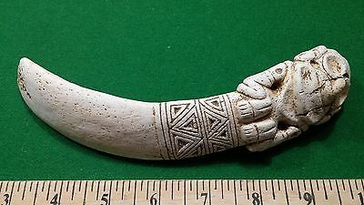

#### [Taino Bone Spatula (Vomet Stick) - Pre Columbian](http://www.ebay.com/itm/272064564749)

|  |  |
| --- | --- |
| Item price | $199.00 |
| Quantity | 1 |
| Item number | 272064564749 |
| Shipping service | Expedited Shipping from outside US |

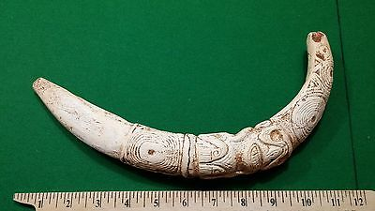

#### [Taino Bone Spatula (Vomet Stick) - Pre Columbian Very Large](http://www.ebay.com/itm/272064572140)

|  |  |
| --- | --- |
| Item price | $199.00 |
| Quantity | 1 |
| Item number | 272064572140 |
| Shipping service | Expedited Shipping from outside US |

## Shipping address

Ralph J Coffman Jr

149 Atlantic Ave

Swampscott MA 01907-2427

United States

## Order total

|  |  |
| --- | --- |
| Subtotal | $665.00 |
| Shipping | $35.00 |

**Total**

$700.00Order placed on

Thursday, Dec 10, 2015

Payment method PayPal

Payment date Thursday, Dec 10, 2015

